**Module 2: Lab 2 Basic Full Stack Labs**

Sushmita Prafull Halasawade

IFT 544: Middleware Prog & Database Sec

Dinesh Sthapit

10 Sep 2023

**Exercise 1: Variables:**

**Output:**

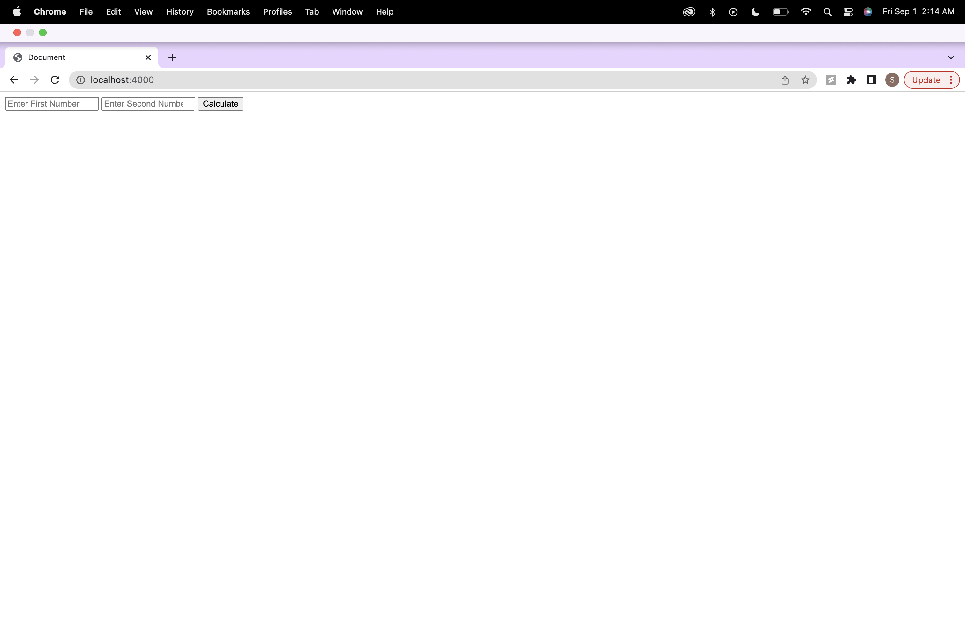

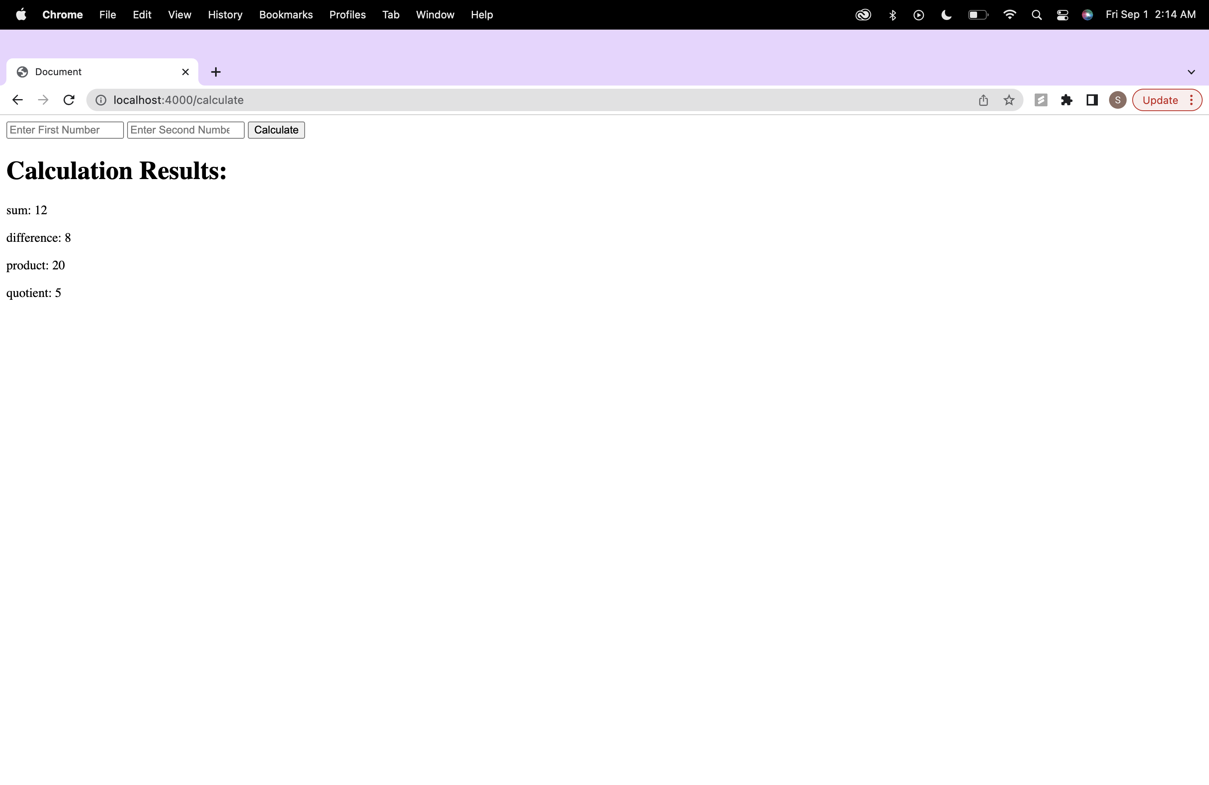

**Exercise 2: Arrays and Objects**

**Output:**

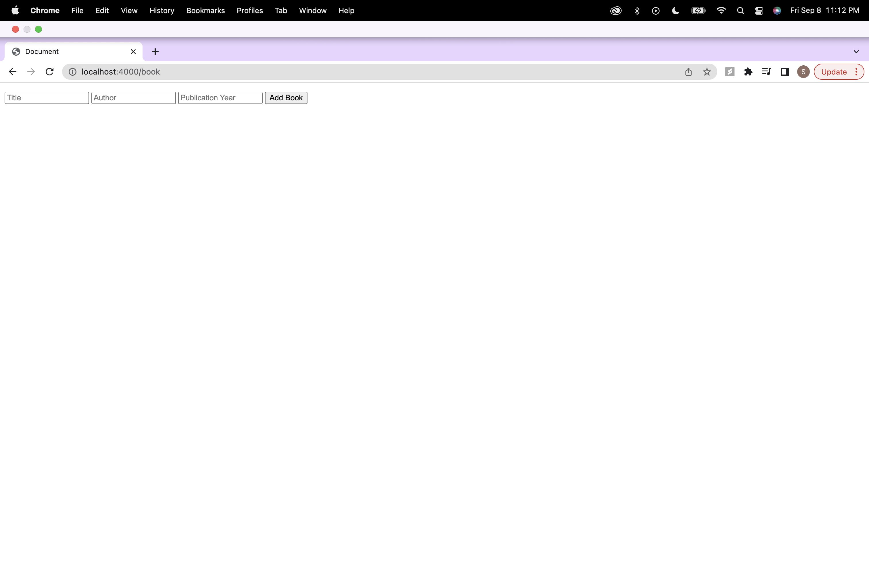

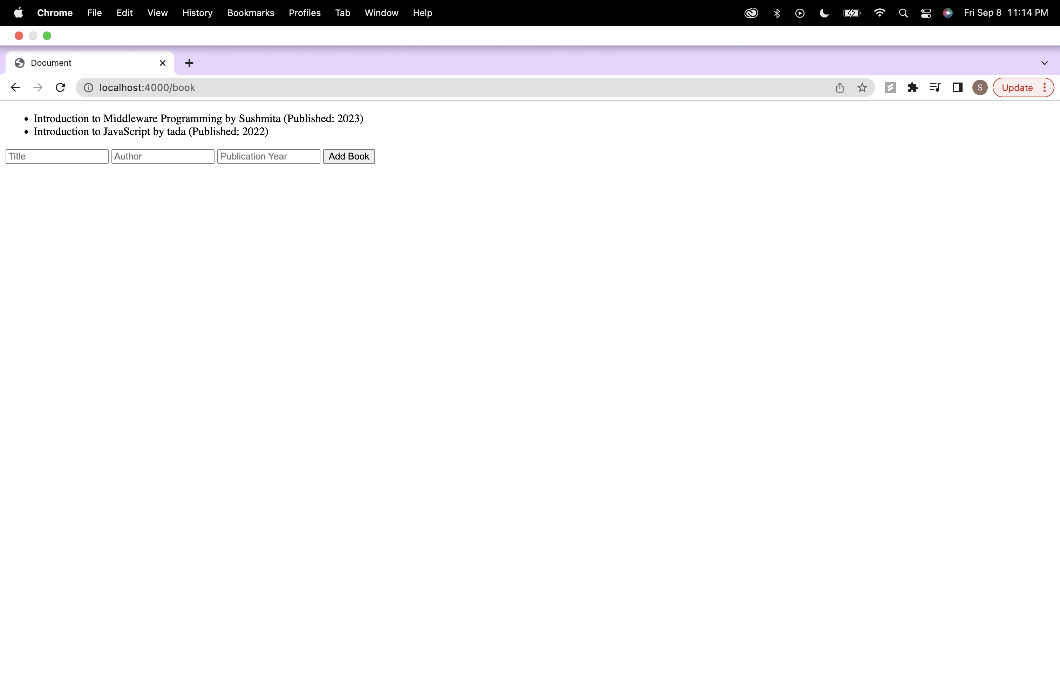

**Step1: Setup:**

Package.json and installation of express,ejs and body

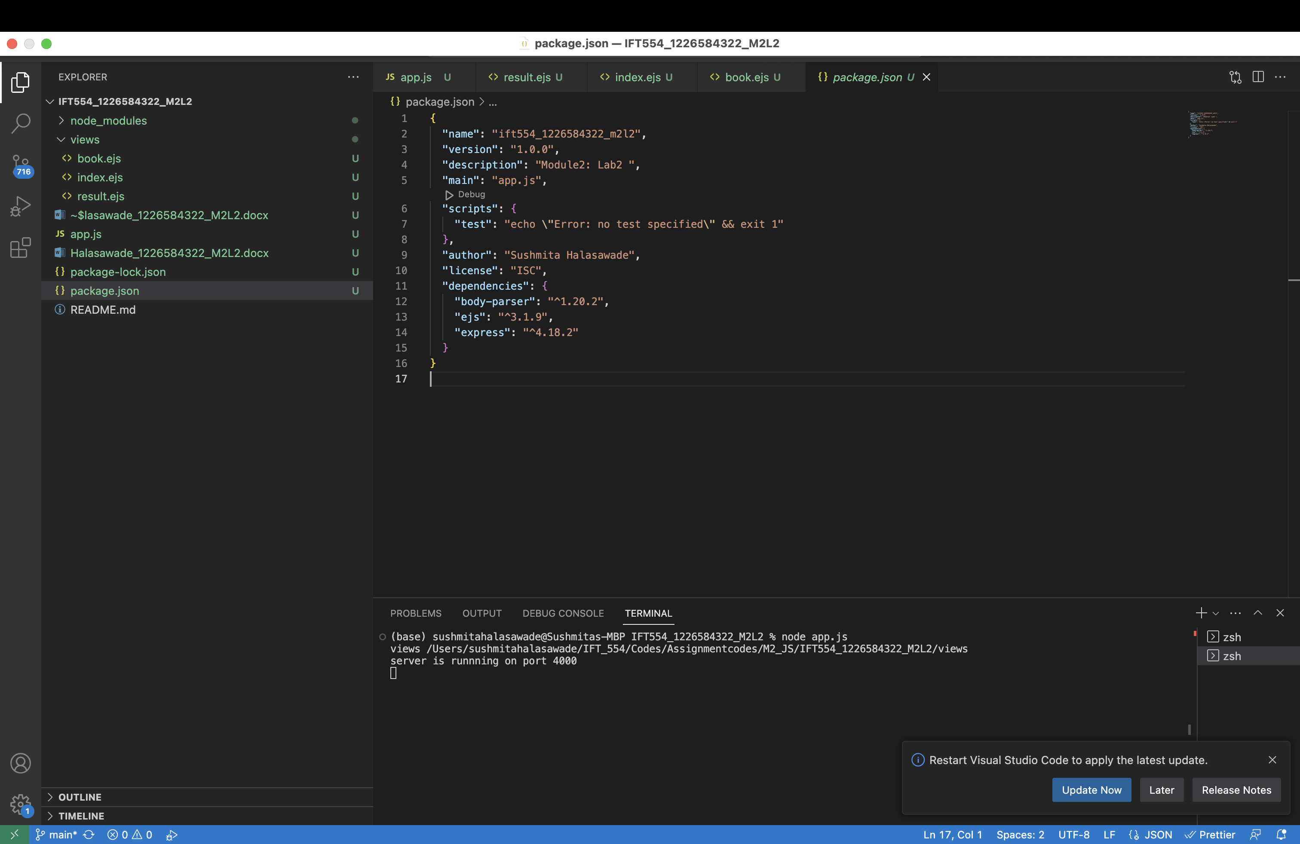

**Step2: .ejs Code Analysis:**

1. Review the .ejs file line by line and identify sections that contain JavaScript code within <% %> tags:

In the book.ejs file, JavaScript code is embedded within <% %> tags. These tags are used to execute JavaScript code within the HTML template. Here are the parts of .ejs file that contain JavaScript code:

book.ejs:

<ul>

<%books.forEach(book=>{%>

<li><%= book.title %> by <%= book.author%> (Published: <%= book.publicationYear%>)</li>

<% }); %>

</ul>

Here, <% books.forEach(book => { %> indicates the beginning of a JavaScript loop. It iterates over the books array and generates list items for each book's title, author, and publication year.

2. Analyze and understand the JavaScript code embedded in the .ejs file, including control structures, variable usage, and EJS-specific syntax:

* Control Structures:The forEach loop is used to iterate through each book in the books array.
* Variable Usage:book.title, book.author, and book.publicationYear are variables representing properties of each book object.
* EJS-specific Syntax:<%= ... %> is used to output the value of a JavaScript variable or expression to the HTML.

3. Take note of any notable features or functionalities implemented in the .ejs file.:

dynamic generation of the list items: HTML is generated based on the data in the books array.

EJS Templating: The file demonstrates the use of EJS as a templating engine for generating dynamic HTML content. EJS tags (<%= ... %>) are employed to insert JavaScript variables and expressions into the HTML structure.

**Step3: HTML Code Analysis:**

1.Open the HTML file in a browser or a code editor:

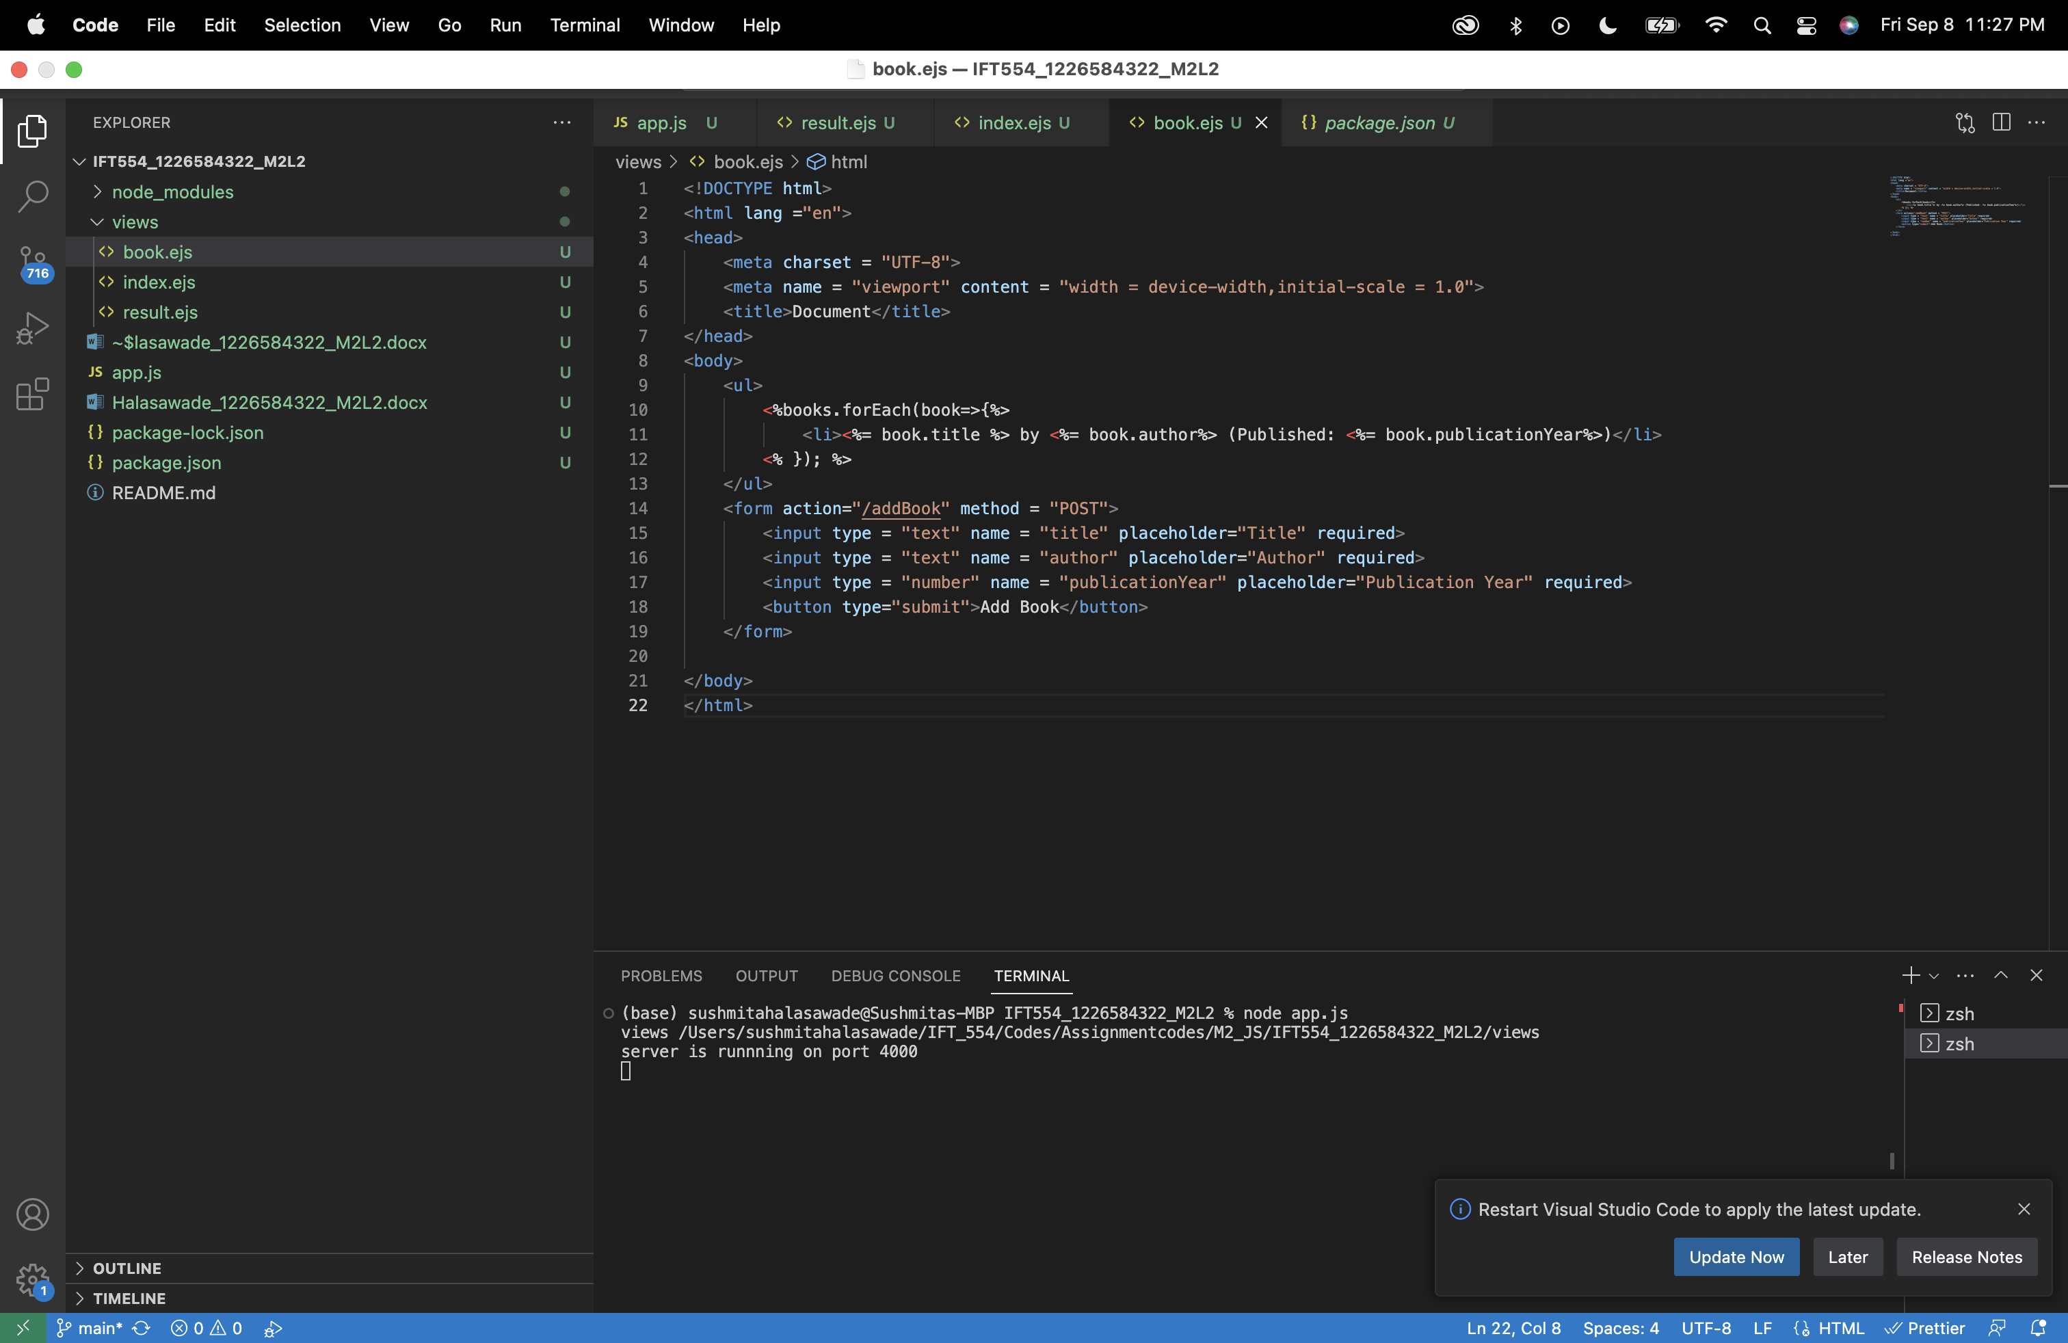

2. Inspect the rendered HTML code in the browser or view the HTML file's source code:

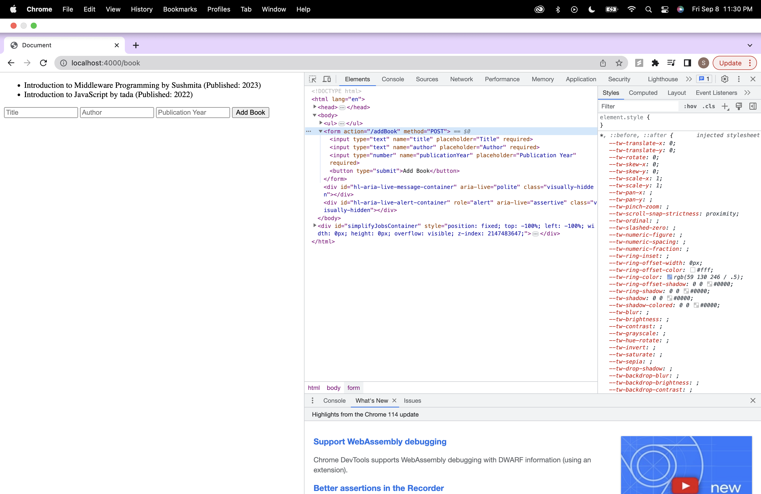

3. Identify the parts of the HTML code that correspond to the JavaScript code in the .ejs file.:

JavaScript code is embedded within <% %> tags. JavaScript code iterates through the books array and generates list items (<li>) dynamically based on the books array. Here are the parts of the HTML code that correspond to JavaScript code:

<ul>

<%books.forEach(book=>{%>

<li><%= book.title %> by <%= book.author%> (Published: <%= book.publicationYear%>)</li>

<% }); %>

</ul>

4. Compare the rendered HTML code to the original .ejs code and note any differences or modifications.:

<body>

<ul>

<li>Introduction to Middleware Programming by Sushmita (Published: 2023)</li>

<li>Introduction to JavaScript by tada (Published: 2022)</li>

</ul>

<form action="/addBook" method="POST">

<input type="text" name="title" placeholder="Title" required="">

<input type="text" name="author" placeholder="Author" required="">

<input type="number" name="publicationYear" placeholder="Publication Year" required="">

<button type="submit">Add Book</button>

</form>

</body>

In the original book.ejs code, JavaScript expressions (<%= %>) are used to dynamically insert values (e.g., book.title, book.author, book.publicationYear) into the HTML elements. In the rendered HTML, these expressions are replaced with actual values.

The <% %> tags in the original book.ejs code are not present in the rendered HTML. They are used for embedding JavaScript logic and are not visible in the final output.

The form action attribute action="/addBook" in the HTML code corresponds to the route defined in the app.js file (app.post("/addBook", ...)) for handling form submissions.

**Step4: documentation:**

1.Analysis Summary:

In this code we are creating a simple web application using Node.js and Express framework. The application allows users to add books with their title, author, and publication year. It uses EJS as the templating engine for rendering dynamic content.

2.Comparison: .ejs vs. HTML:

book.ejs (.ejs Code):

<body>

<ul>

<%books.forEach(book=>{%>

<li><%= book.title %> by <%= book.author%> (Published: <%= book.publicationYear%>)</li>

<% }); %>

</ul>

<form action="/addBook" method = "POST">

<input type = "text" name = "title" placeholder="Title" required>

<input type = "text" name = "author" placeholder="Author" required>

<input type = "number" name = "publicationYear" placeholder="Publication Year" required>

<button type="submit">Add Book</button>

</form>

HTML Code Generated in the Browser:

<body>

<ul>

<li>Introduction to Middleware Programming by Sushmita (Published: 2023)</li>

<li>Introduction to JavaScript by tada (Published: 2022)</li>

</ul>

<form action="/addBook" method="POST">

<input type="text" name="title" placeholder="Title" required="">

<input type="text" name="author" placeholder="Author" required="">

<input type="number" name="publicationYear" placeholder="Publication Year" required="">

<button type="submit">Add Book</button>

</form>

</body>



3.Observations and Differences:

EJS templates allow you to inject dynamic data (e.g., book titles, authors) directly into your HTML structure, making it easier to create dynamic web pages.

The <%books.forEach(book=>{%> loop in the EJS template enables you to iterate through the books array and generate list items for each book.

4.Benefits of Using .ejs Templates:

Dynamic Content: .ejs templates allow us to inject dynamic data into your HTML, making it easier to display results or user-specific information.

Reusability: .ejs templates can be reused across different pages, reducing code duplication.

Maintainability: It separates code logic (in JavaScript) from the presentation (in .ejs files), making it easier to maintain and update.

**Step5: Optional Enhancement:**

Modified result.ejs:

<ul>

<%books.forEach(book=>{%>

<li><%= book.title %> by <%= book.author%> (Published: <%= book.publicationYear%>

<% if (book.publicationYear >= 2020) { %>

<span style="color: green;">(New)</span>

<% } else { %>

<span style="color: red;">(Old)</span>

<% } %>)</li>

<% }); %>

</ul>

I've added a conditional statement (if-else) that checks if the publicationYear of a book is greater than or equal to 2020. If it is, it adds a green "(New)" label next to the book title; otherwise, it adds a red "(Old)" label.

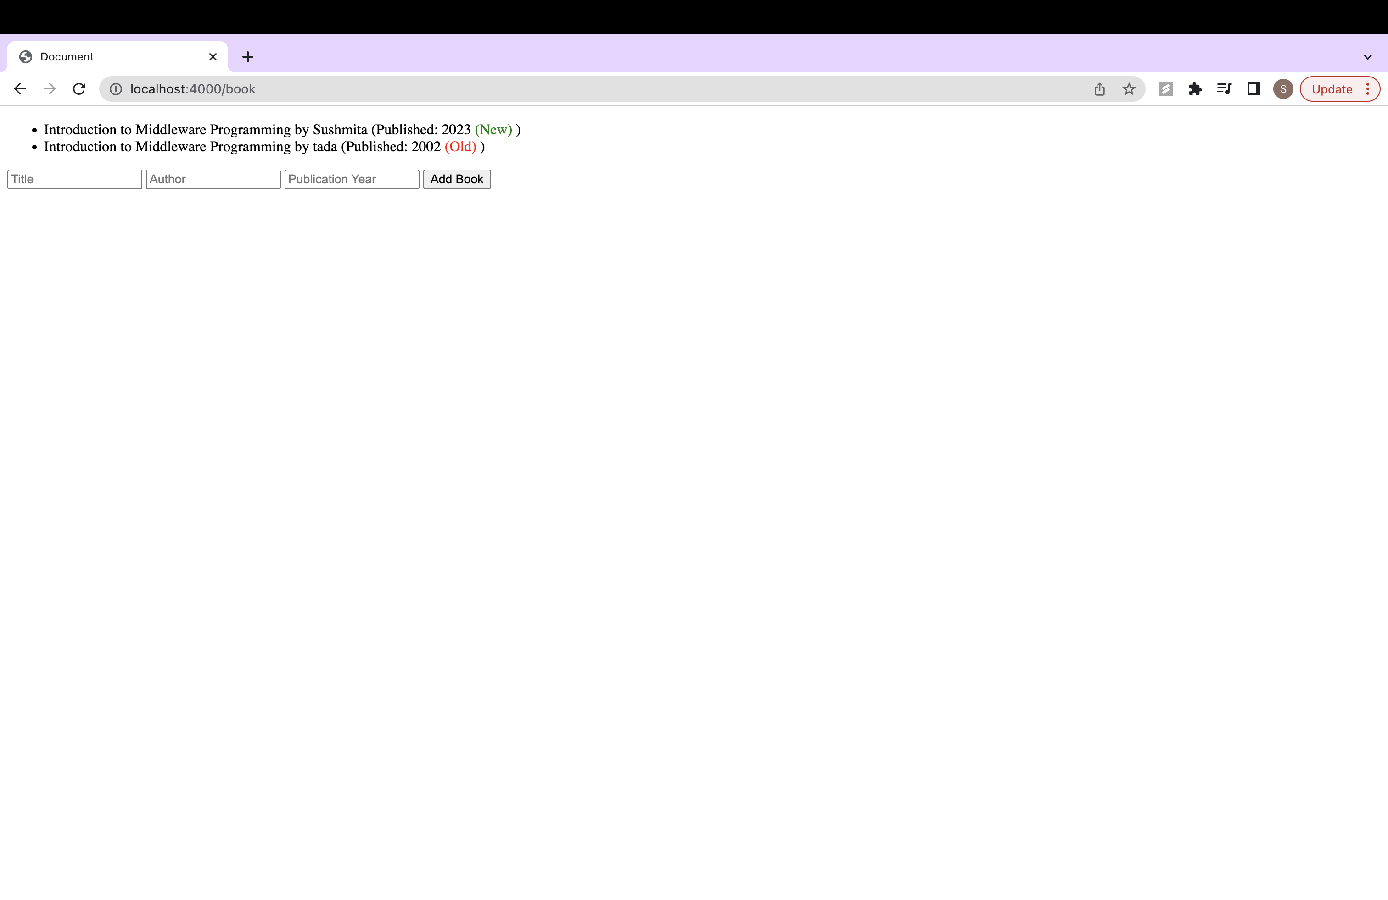

2. Analyze the corresponding changes in the rendered HTML code and document your findings.

Rendered HTML:

<ul>

<li>Introduction to Middleware Programming by Sushmita (Published: 2023

<span style="color: green;">(New)</span>

)</li>

<li>Introduction to Middleware Programming by tada (Published: 2002

<span style="color: red;">(Old)</span>

)</li>

</ul>

In this example, 1st book is marked as "(New)" because its publication year is 2023(2022 or later). While 2nd book is marked as "(Old)" because its publication year is assumed to be before 2020.

**Exercise 3: Constructors and DE structuring**

**Output:**

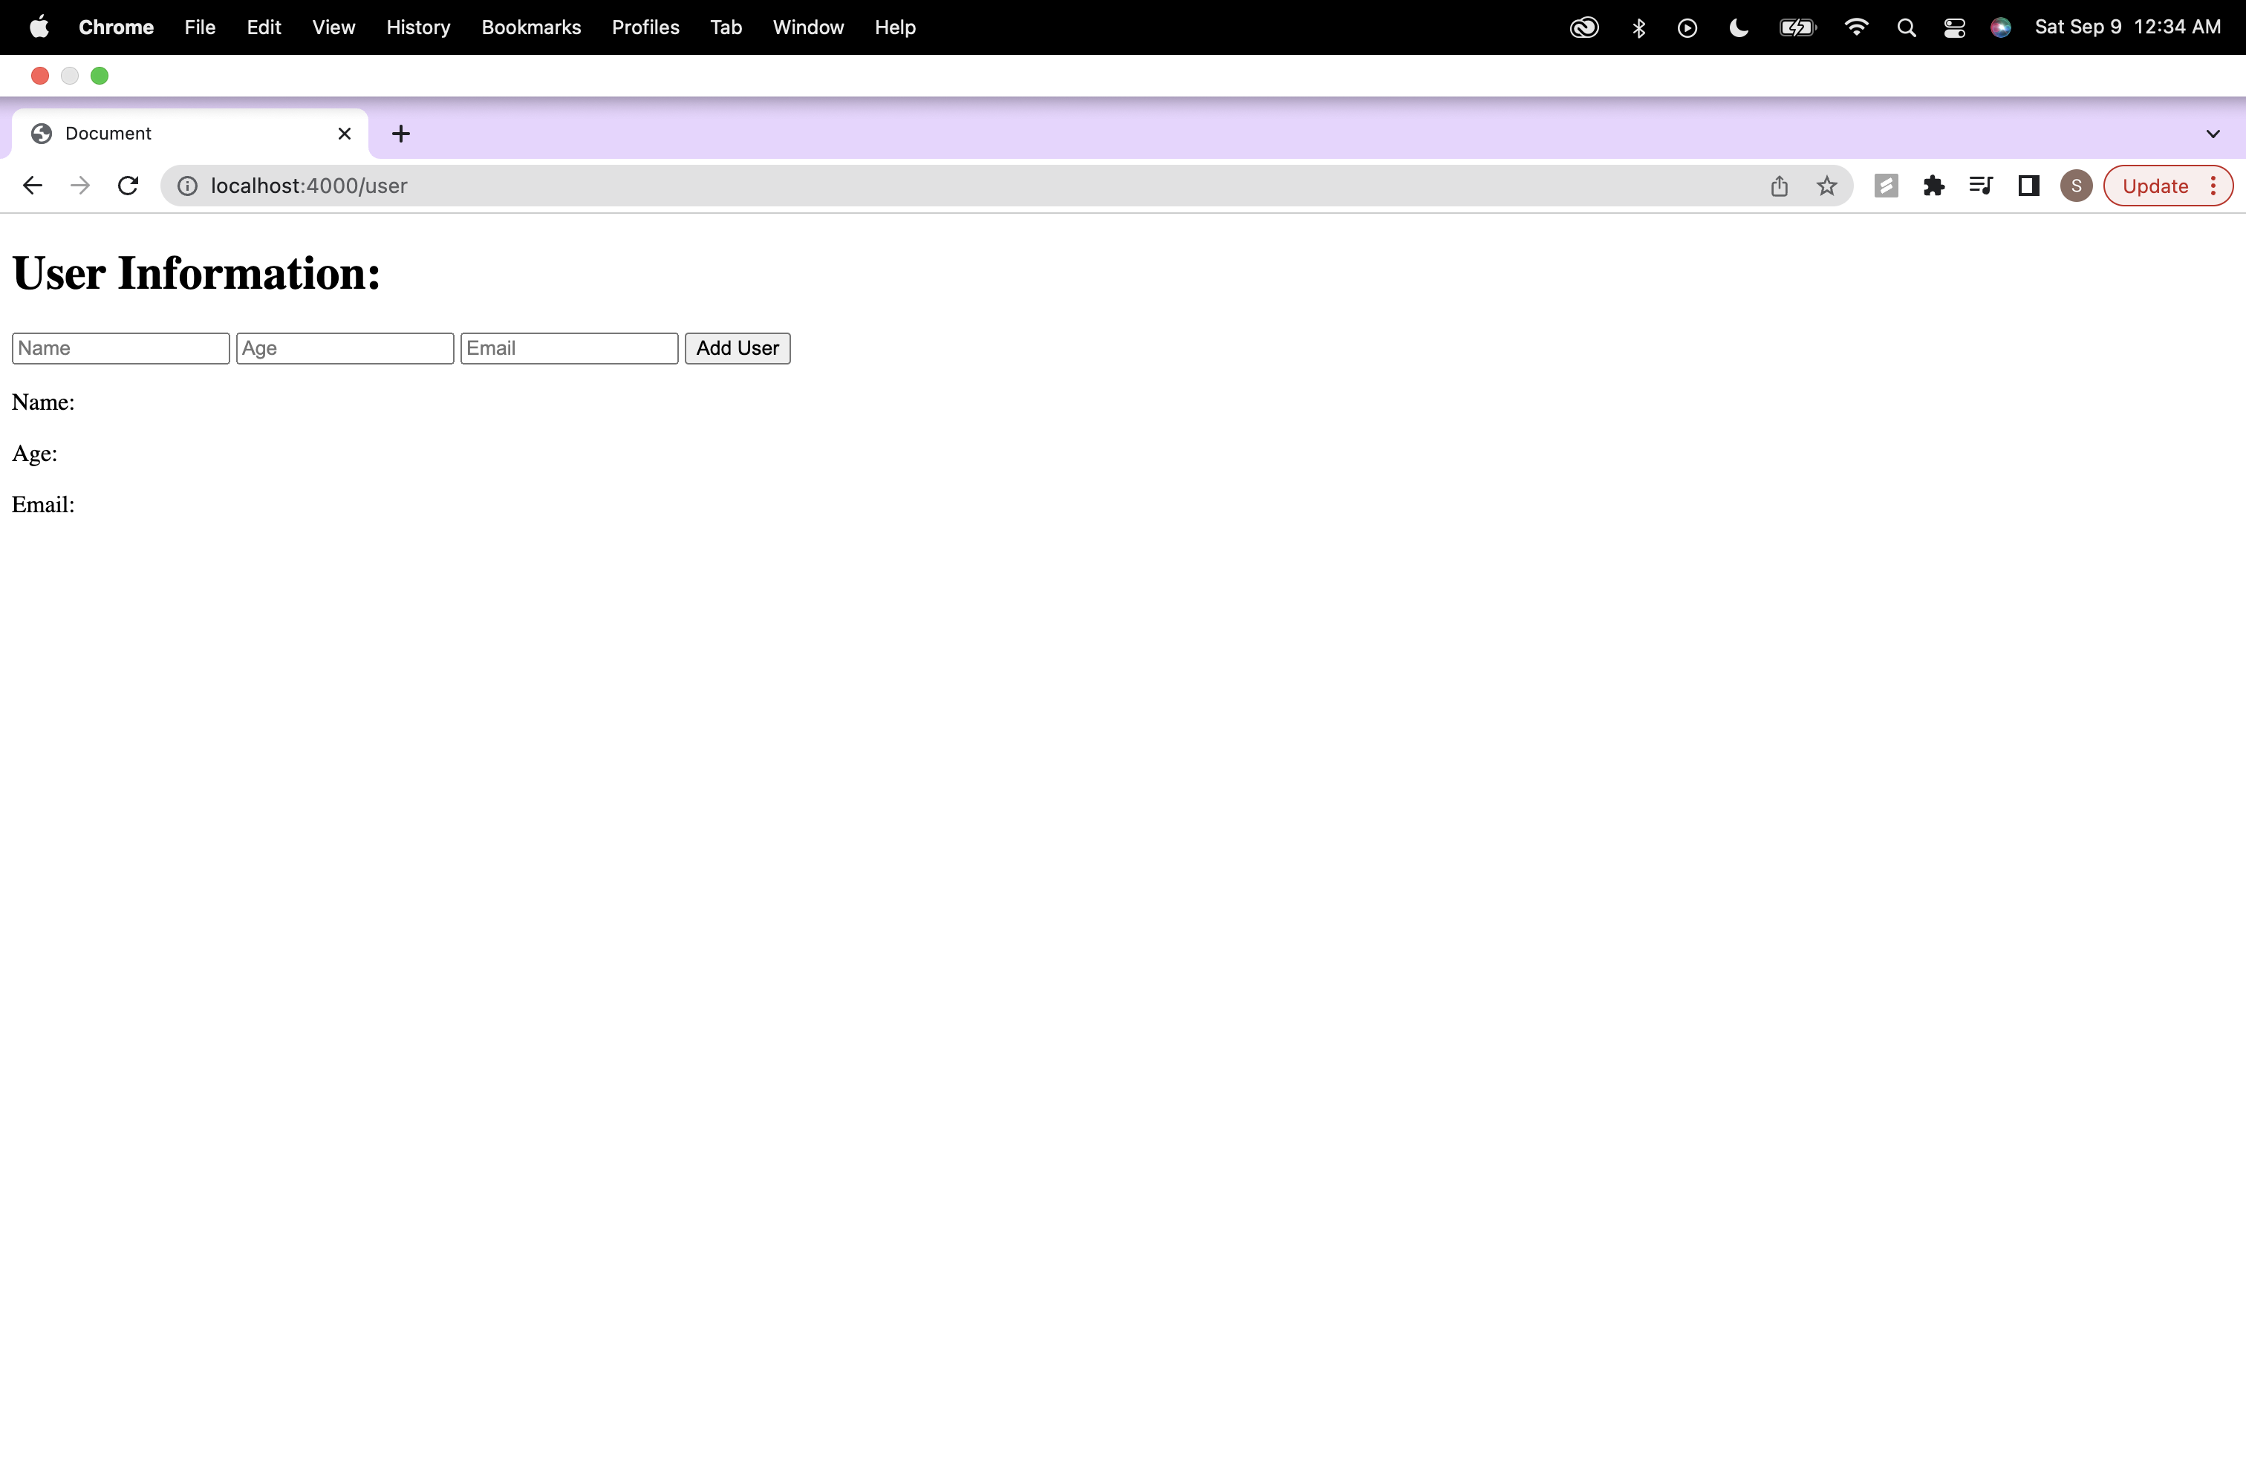

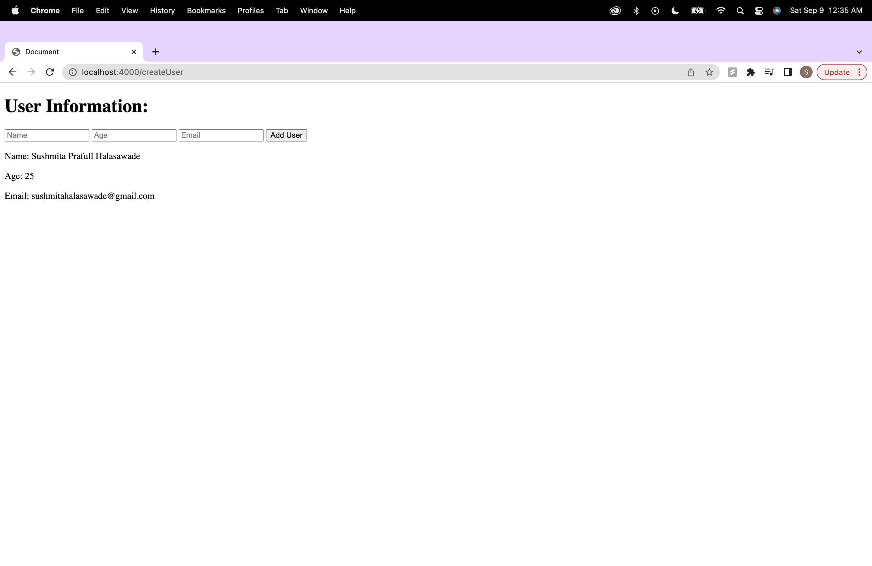

**Step2: .ejs Code Analysis:**

1. Review the .ejs file line by line and identify sections that contain JavaScript code within <% %> tags:

In the userInfo.ejs file, JavaScript code is embedded within <% %> tags. Here are the parts of .ejs file that contain JavaScript code:

userInfo.ejs:

<p>Name: <%=userName %></p>

<p>Age: <%=userAge %></p>

<p>Email: <%=userEmail %></p>

2. Analyze and understand the JavaScript code embedded in the .ejs file, including control structures, variable usage, and EJS-specific syntax:

In the .ejs file, JavaScript code within <% %> tags is used to embed variables (userName, userAge, and userEmail) into the HTML content. The variables are enclosed within <%= %> tags to indicate that their values should be displayed in the rendered HTML.

3. Take note of any notable features or functionalities implemented in the .ejs file.:

The .ejs file is a template for rendering user information, and it includes an HTML form for creating a user. When a user submits the form, the data is sent to the server for processing.

**Step3: HTML Code Analysis:**

1.Open the HTML file in a browser or a code editor:

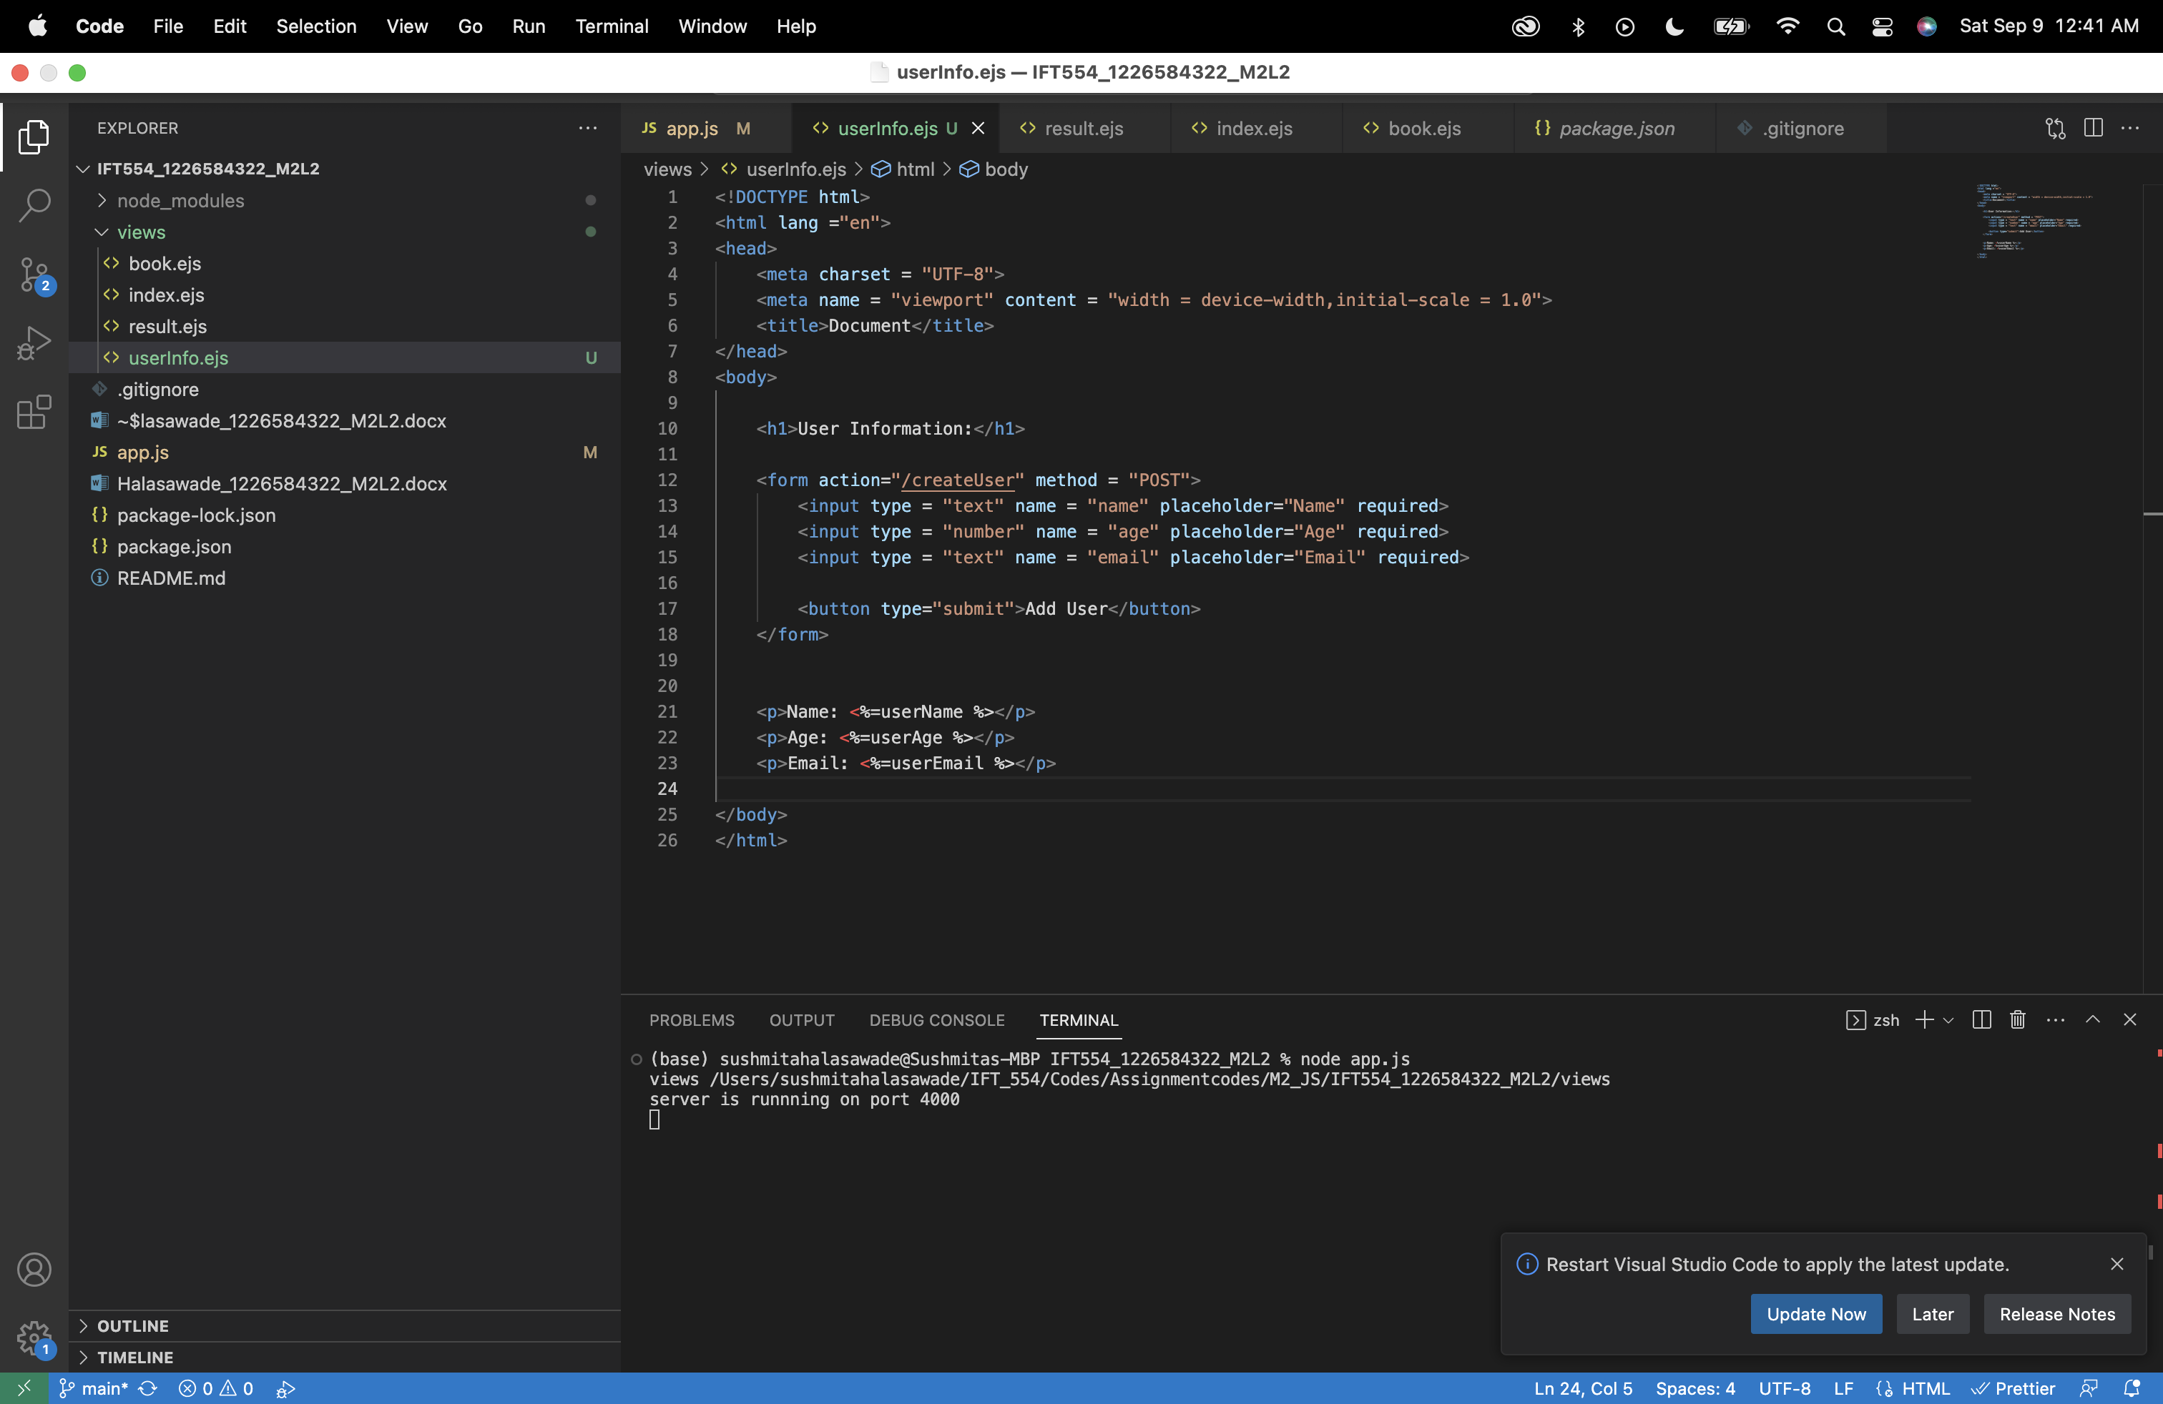

2. Inspect the rendered HTML code in the browser or view the HTML file's source code:

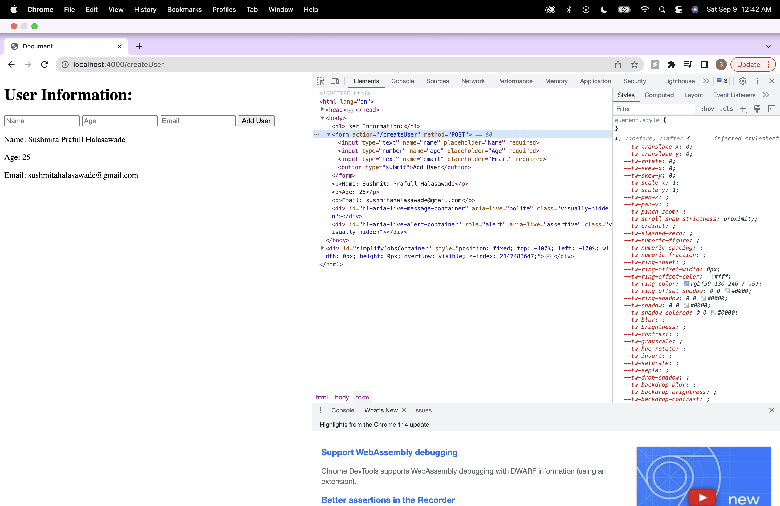

3. Identify the parts of the HTML code that correspond to the JavaScript code in the .ejs file.:

The JavaScript code within <% %> tags is used to display user information within the HTML document.:

<p>Name: <%=userName %></p>

<p>Age: <%=userAge %></p>

<p>Email: <%=userEmail %></p>

4. Compare the rendered HTML code to the original .ejs code and note any differences or modifications.:

<body>

<h1>User Information:</h1>

<form action="/createUser" method="POST">

<input type="text" name="name" placeholder="Name" required="">

<input type="number" name="age" placeholder="Age" required="">

<input type="text" name="email" placeholder="Email" required="">

<button type="submit">Add User</button>

</form>

<p>Name: Sushmita Prafull Halasawade</p>

<p>Age: 25</p>

<p>Email: sushmitahalasawade@gmail.com</p> </body>

The rendered HTML code will include the user's name, age, and email provided through post response in place of <%=userName %>, <%=userAge %>, and <%=userEmail %>.

**Step4: documentation:**

1.Analysis Summary:

The .ejs file serves as a template for rendering user information. It uses EJS tags to embed JavaScript code for displaying user data within the HTML content.

2.Comparison: .ejs vs. HTML:

userInfo.ejs (.ejs Code):

<body>

<h1>User Information:</h1>

<form action="/createUser" method = "POST">

<input type = "text" name = "name" placeholder="Name" required>

<input type = "number" name = "age" placeholder="Age" required>

<input type = "text" name = "email" placeholder="Email" required>

<button type="submit">Add User</button>

</form>

<p>Name: <%=userName %></p>

<p>Age: <%=userAge %></p>

<p>Email: <%=userEmail %></p>

</body>

HTML Code Generated in the Browser:

<body>

<h1>User Information:</h1>

<form action="/createUser" method="POST">

<input type="text" name="name" placeholder="Name" required="">

<input type="number" name="age" placeholder="Age" required="">

<input type="text" name="email" placeholder="Email" required="">

<button type="submit">Add User</button>

</form>

<p>Name: Sushmita Prafull Halasawade</p>

<p>Age: 25</p>

<p>Email: sushmitahalasawade@gmail.com</p> </body>



3.Observations and Differences:

The HTML content within the .ejs file contains placeholders (<%=userName %>, <%=userAge %>, <%=userEmail %>) for user data, which are filled in with actual user information when the template is rendered by the server. This approach allows the template to display user data dynamically without the need for static HTML content for each user.

**Step5: Optional Enhancement:**

Modified result.ejs:

<ul>

<%books.forEach(book=>{%>

<li><%= book.title %> by <%= book.author%> (Published: <%= book.publicationYear%>

<% if (book.publicationYear >= 2020) { %>

<span style="color: green;">(New)</span>

<% } else { %>

<span style="color: red;">(Old)</span>

<% } %>)</li>

<% }); %>

</ul>

In .ejs file, I've added an <ul> element to display a list of users. We use EJS templating to iterate over an array called users. For each user in the array, we display their name, age, and email.

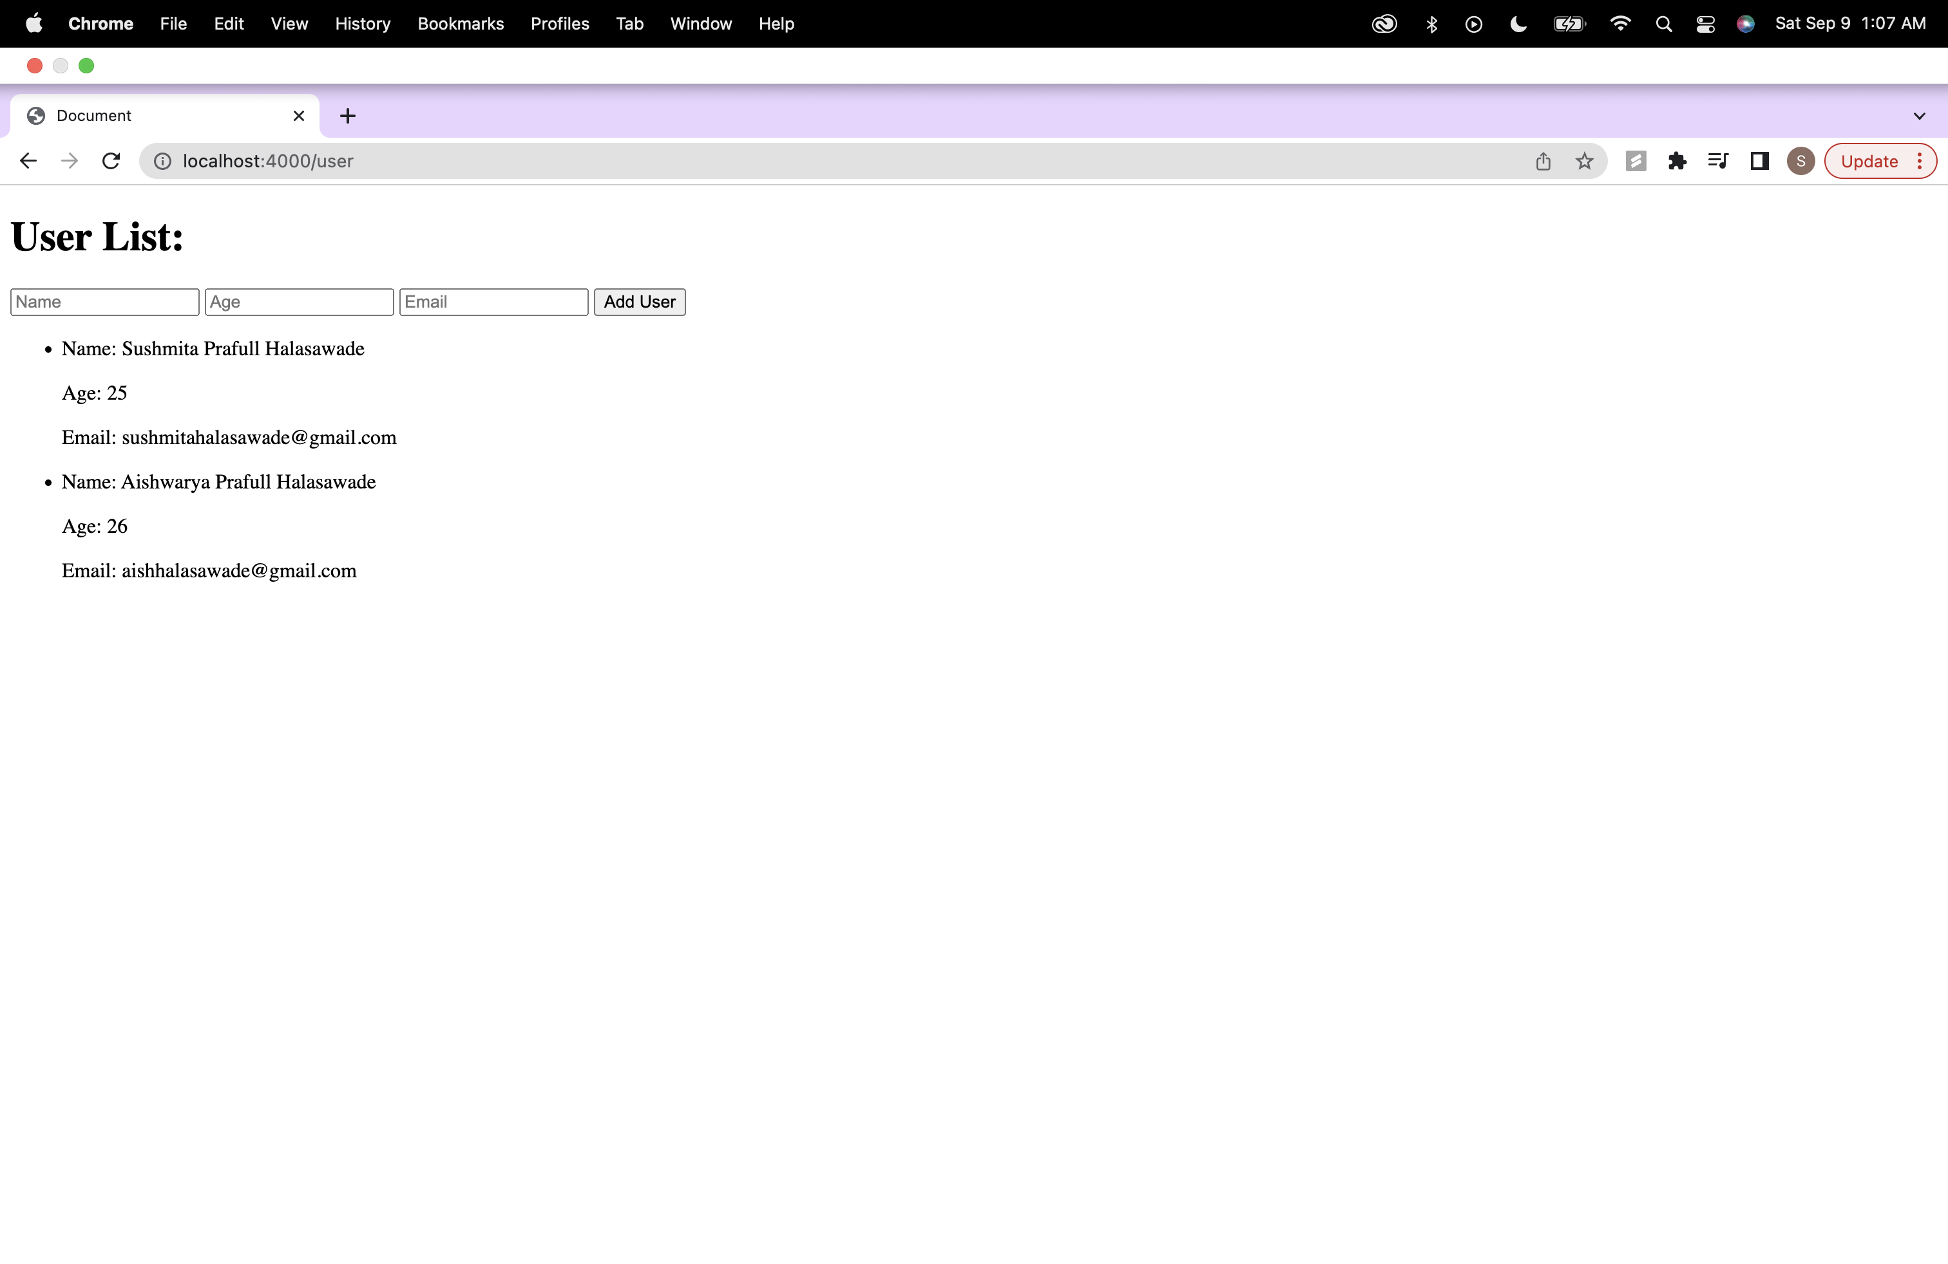

2. Analyze the corresponding changes in the rendered HTML code and document your findings.

Rendered HTML:

<body>

<h1>User List:</h1>

<form action="/createUser" method="POST">

<input type="text" name="name" placeholder="Name" required="">

<input type="number" name="age" placeholder="Age" required="">

<input type="text" name="email" placeholder="Email" required="">

<button type="submit">Add User</button>

</form>

<ul>

<li>

<p>Name: Sushmita Prafull Halasawade</p>

<p>Age: 25</p>

<p>Email: sushmitahalasawade@gmail.com</p>

</li>

<li>

<p>Name: Aishwarya Prafull Halasawade</p>

<p>Age: 26</p>

<p>Email: aishhalasawade@gmail.com</p>

</li>

</ul>

The HTML page will now display a list of users with their information in an unordered list (<ul>). The user information is obtained from the user’s array, which is iterated using EJS.

**Exercise 4: Spread Operator**

**Output:**

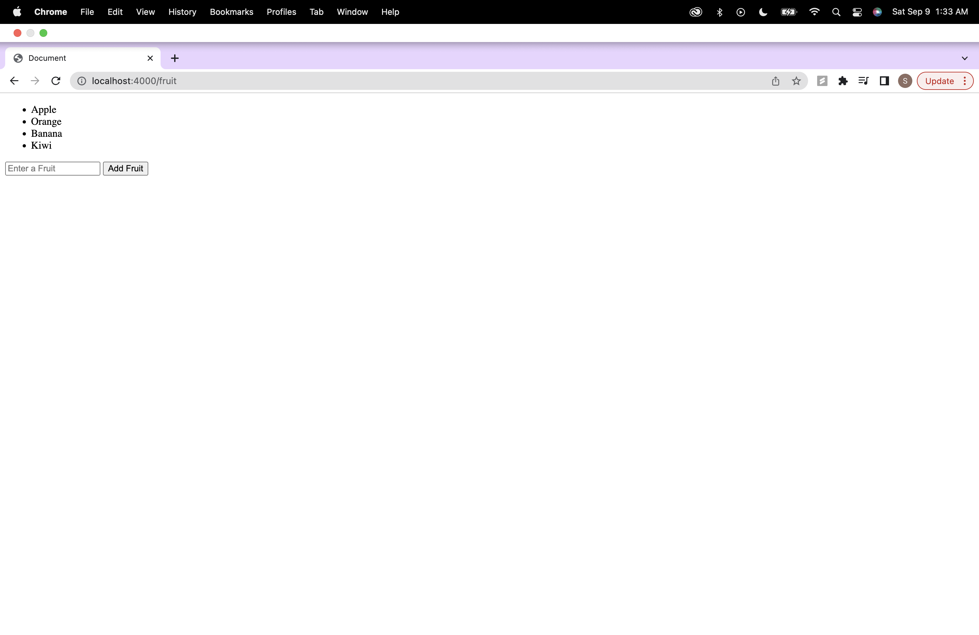

**Step2: .ejs Code Analysis:**

1. Review the .ejs file line by line and identify sections that contain JavaScript code within <% %> tags:

In the fruits.ejs file, JavaScript code is embedded within <% %> tags. Here are the parts of .ejs file that contain JavaScript code:

fruits.ejs:

<ul>

<%fruits.forEach(fruit=>{%>

<li><%= fruit %></li>

<% }); %>

</ul>

2. Analyze and understand the JavaScript code embedded in the .ejs file, including control structures, variable usage, and EJS-specific syntax:

The JavaScript code in the .ejs file is used for rendering a list of fruits dynamically. It iterates through an array called fruits and generates list items for each fruit using <li> tags. EJS-specific syntax like <%= fruit %> is used to insert the value of the fruit variable into the HTML.

3. Take note of any notable features or functionalities implemented in the .ejs file.:

Notable features in the .ejs file include:

Iterating through an array (fruits) and dynamically generating list items.

Using EJS syntax to insert dynamic content into the HTML.

**Step3: HTML Code Analysis:**

1.Open the HTML file in a browser or a code editor:

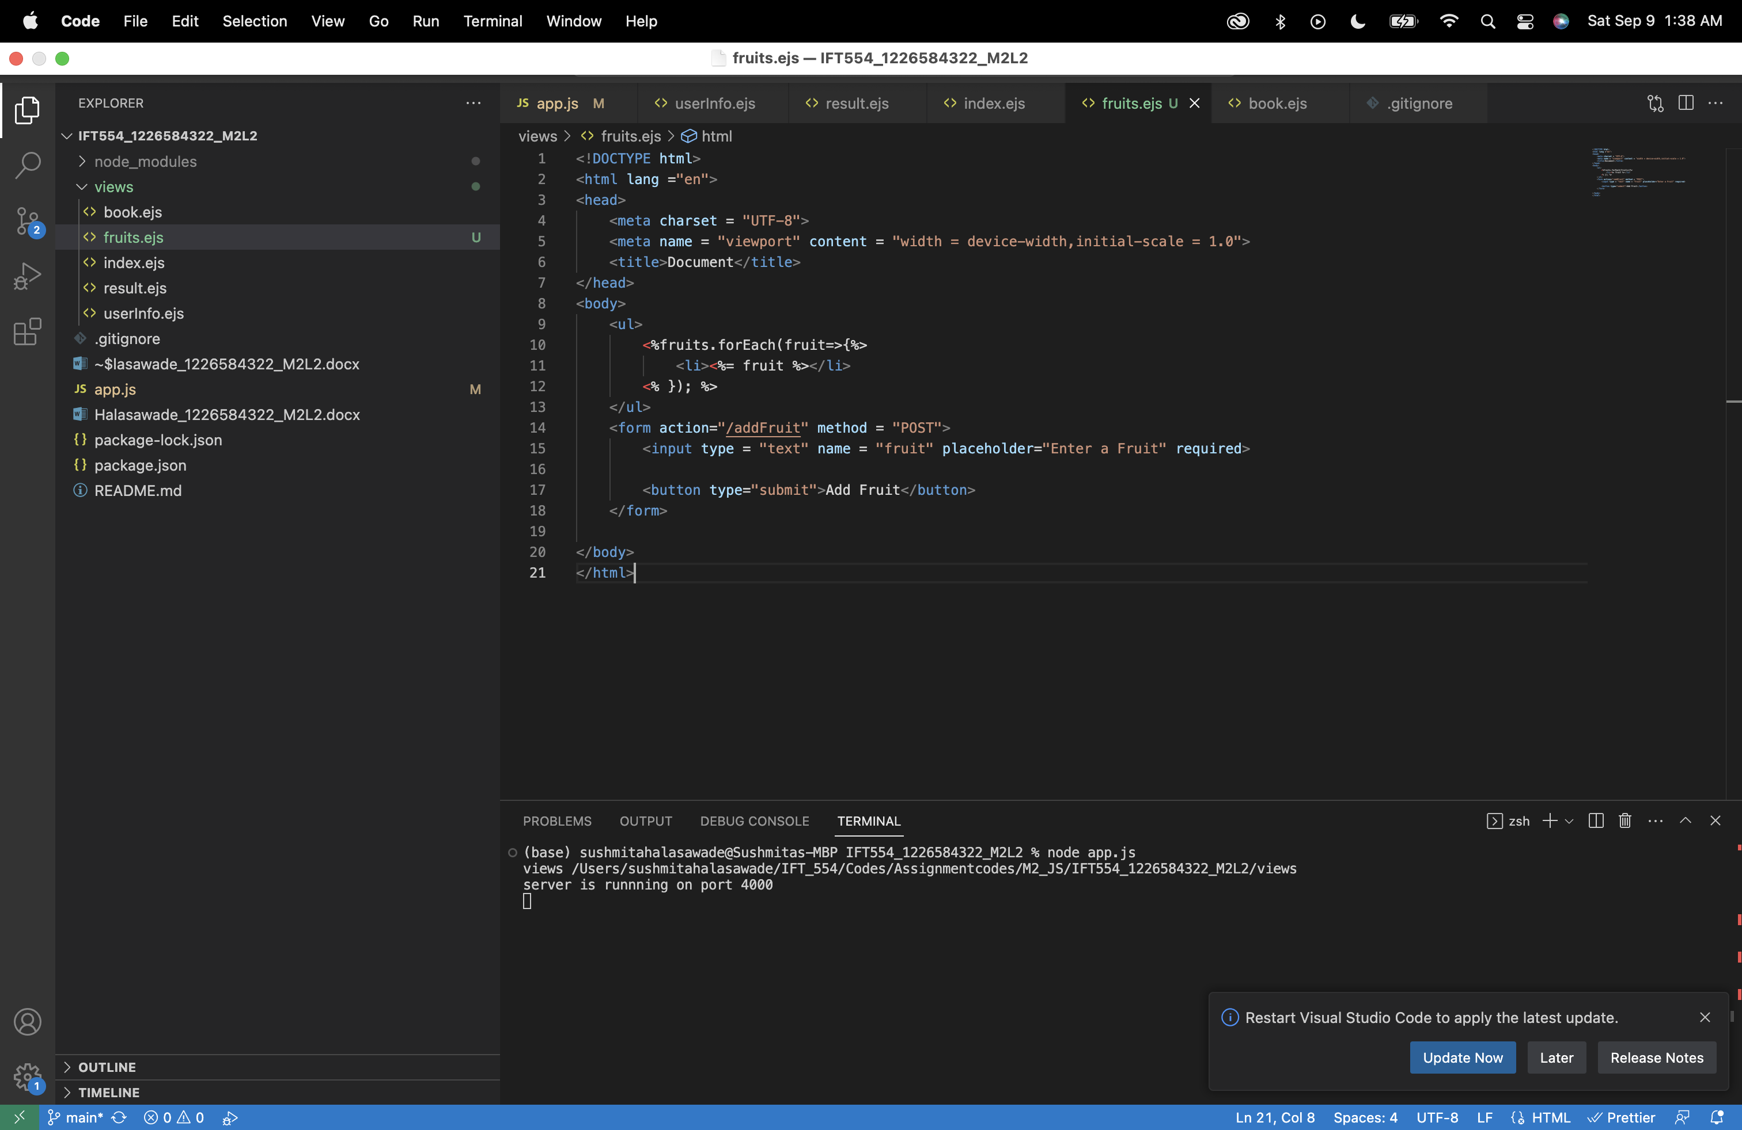

2. Inspect the rendered HTML code in the browser or view the HTML file's source code:

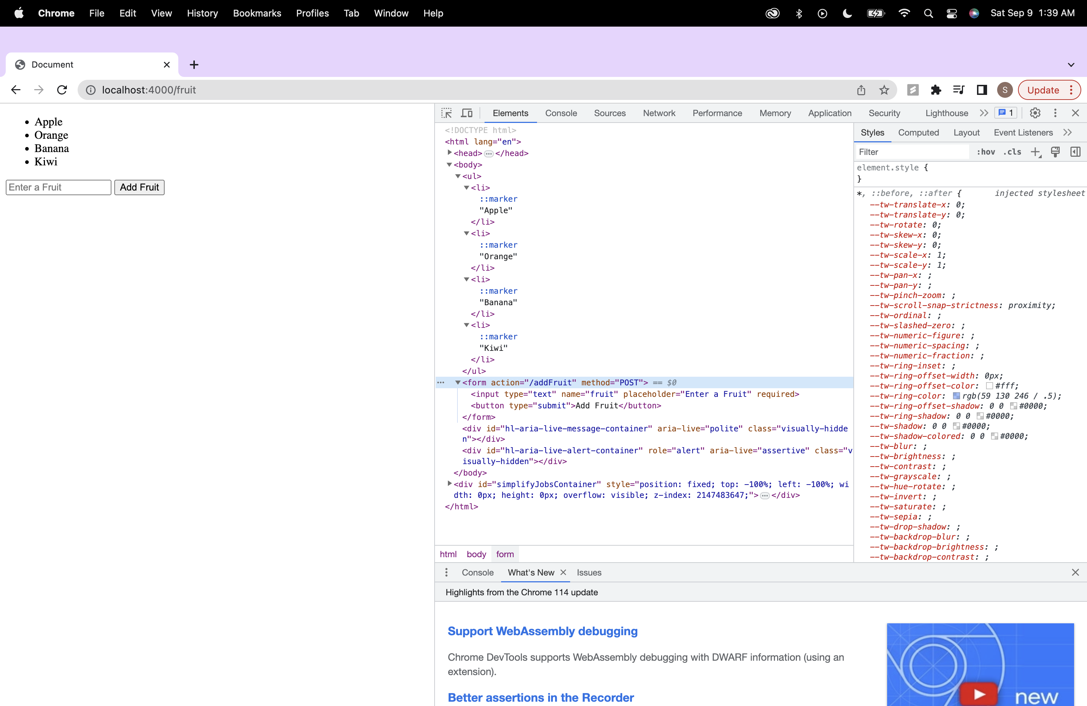

3. Identify the parts of the HTML code that correspond to the JavaScript code in the .ejs file.:

The JavaScript code within <% %> tags is used to display user information within the HTML document.:

<ul>

<%fruits.forEach(fruit=>{%>

<li><%= fruit %></li>

<% }); %>

</ul>

4. Compare the rendered HTML code to the original .ejs code and note any differences or modifications.:

<ul>

<li>Apple</li>

<li>Orange</li>

<li>Banana</li>

<li>Kiwi</li>

</ul>

<form action="/addFruit" method="POST">

<input type="text" name="fruit" placeholder="Enter a Fruit" required="">

<button type="submit">Add Fruit</button>

</form>

The primary difference is that the JavaScript code within <% %> tags is executed, and its output is inserted into the HTML. In the original .ejs code, we can see the JavaScript logic, while in the rendered HTML, we see the actual list of fruits and form.

**Step4: documentation:**

1.Analysis Summary:

The .ejs file uses EJS-specific syntax to insert values from the "fruits" array into the HTML template.The JavaScript code iterates over the array to create list items.

2.Comparison: .ejs vs. HTML:

fruits.ejs (.ejs Code):

<body>

<ul>

<%fruits.forEach(fruit=>{%>

<li><%= fruit %></li>

<% }); %>

</ul>

<form action="/addFruit" method = "POST">

<input type = "text" name = "fruit" placeholder="Enter a Fruit" required>

<button type="submit">Add Fruit</button>

</form>

</body>

HTML Code Generated in the Browser:

<ul>

<li>Apple</li>

<li>Orange</li>

<li>Banana</li>

<li>Kiwi</li>

</ul>

<form action="/addFruit" method="POST">

<input type="text" name="fruit" placeholder="Enter a Fruit" required="">

<button type="submit">Add Fruit</button>

</form>



3.Observations and Differences:

The original .ejs code includes JavaScript control structures to handle dynamic content generation. The rendered HTML will display a list of fruits based on the "fruits" array provided in the JavaScript code.The final HTML output will contain the list items within the <ul> element, with each item displaying a fruit from the array.

**Step5: Optional Enhancement:**

Modified fruits.ejs:

<% if (fruits.length > 0) { %>

<ul>

<% fruits.forEach(fruit => { %>

<li><%= fruit %></li>

<% }); %>

</ul>

<% } else { %>

<p>No fruits available.</p>

<% } %>

In .ejs file, I've added a conditional check, it checks if there are fruits in the array, and if so, it displays the list; otherwise, it shows a message.

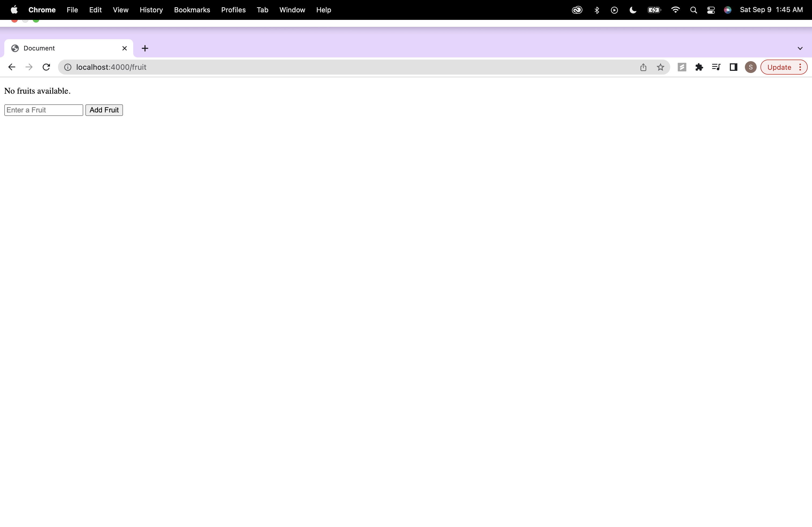

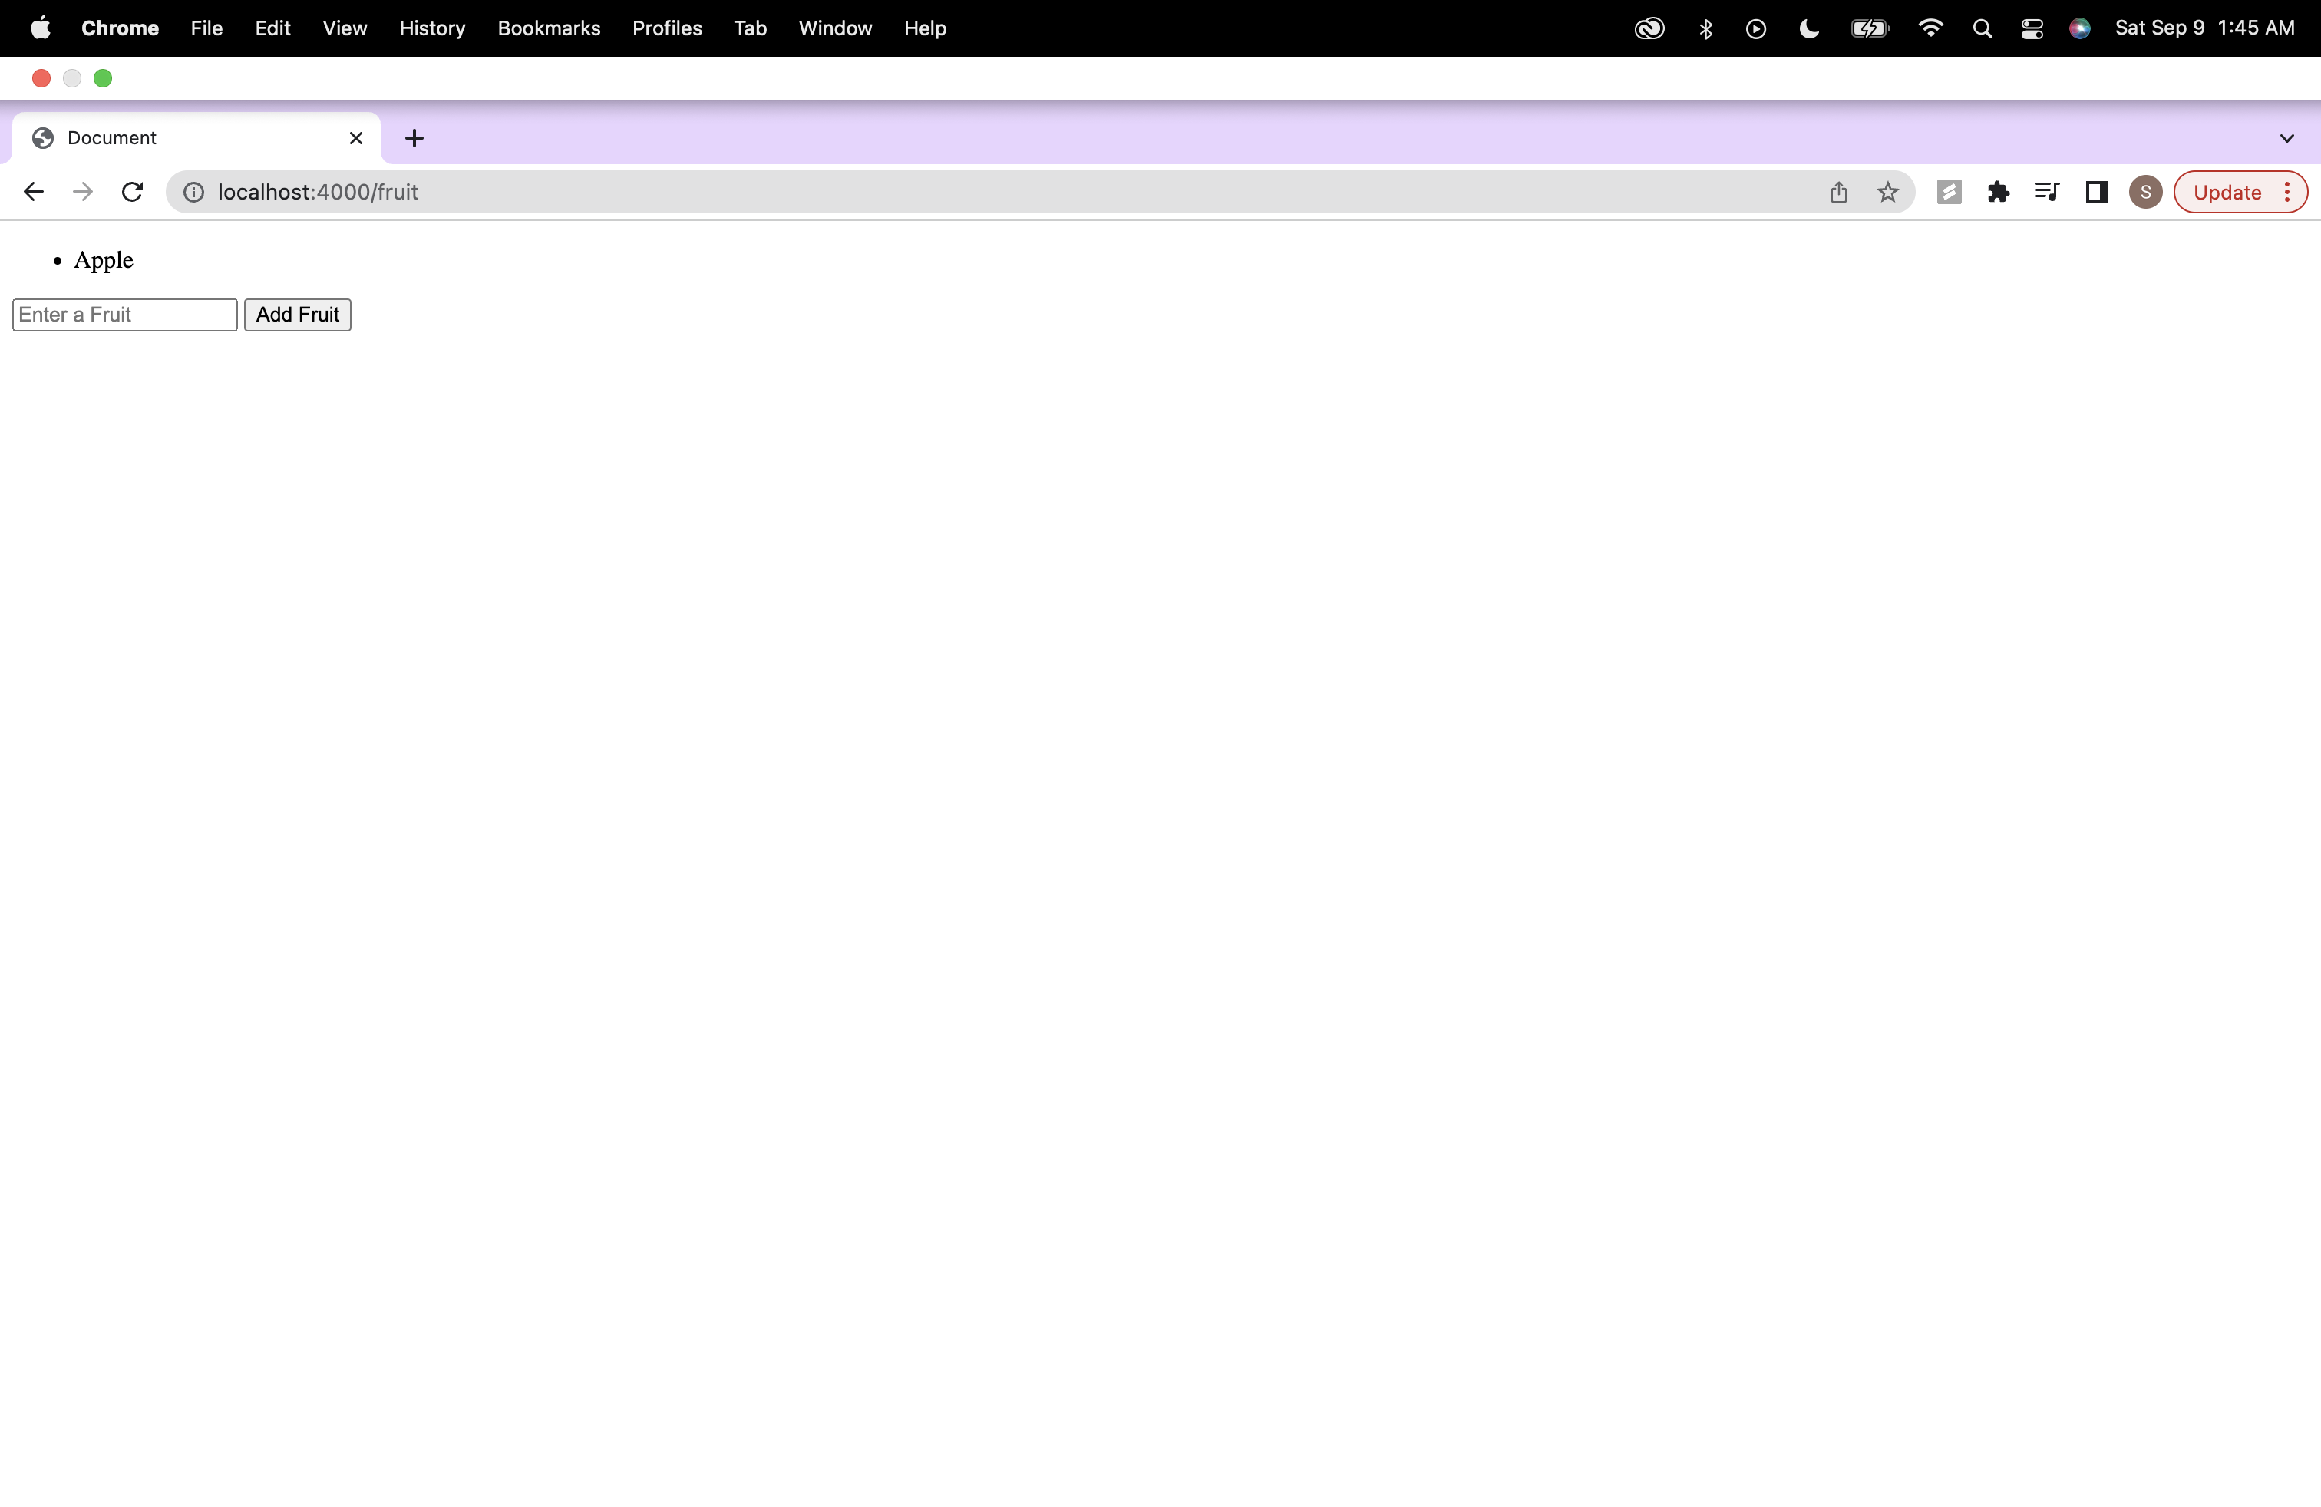

2. Analyze the corresponding changes in the rendered HTML code and document your findings.

Rendered HTML:

<body>

<ul>

<li>Apple</li>

</ul>

<form action="/addFruit" method="POST">

<input type="text" name="fruit" placeholder="Enter a Fruit" required="">

<button type="submit">Add Fruit</button>

</form>

If there are fruits in the array, it will generate an unordered list (<ul>) with list items (<li>) for each fruit.If there are no fruits in the array (empty array), it will display a paragraph (<p>) with the message "No fruits available."

**Exercise 5: Promises**

**Output:**

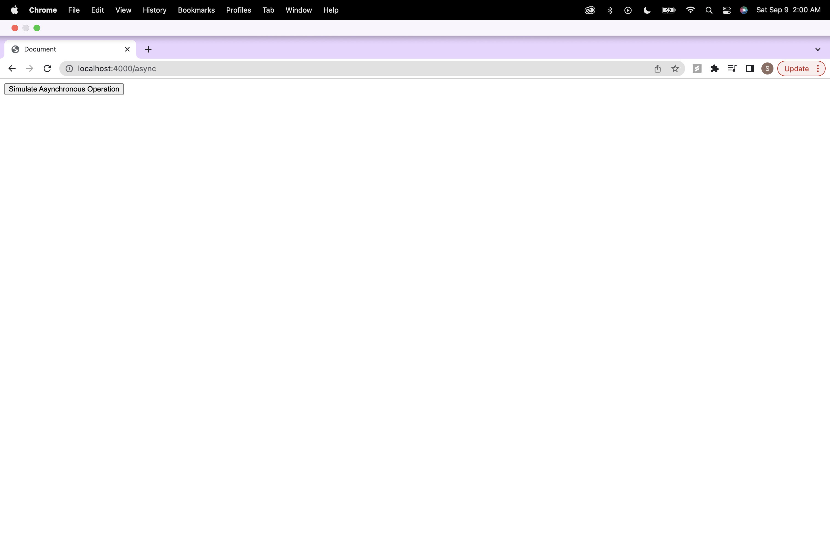

On clicking async button:

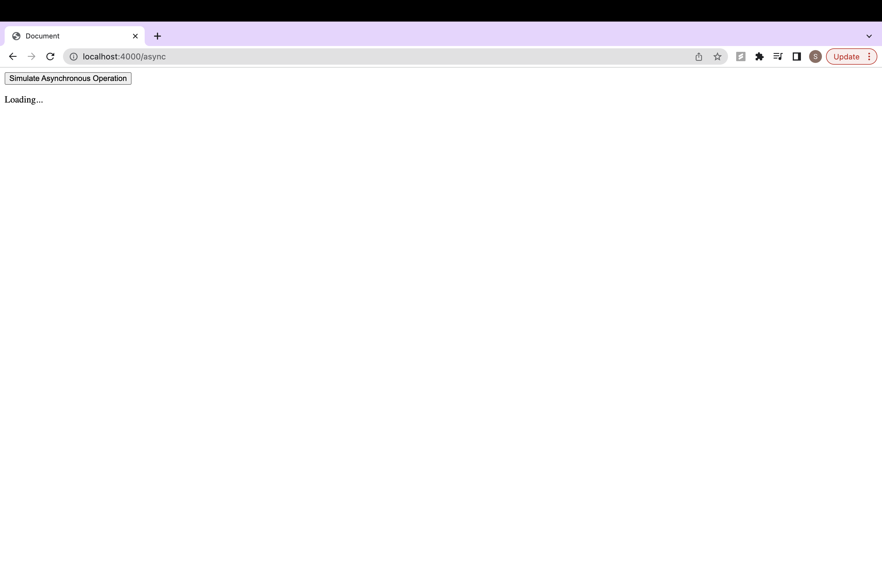

After 2000 ms:

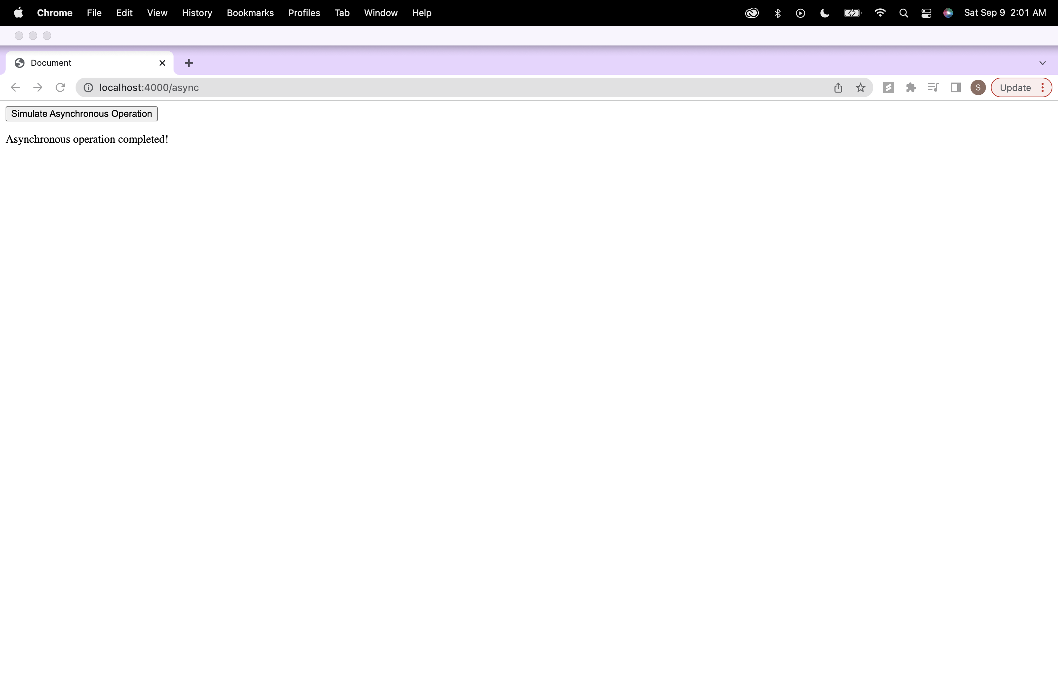

**Step2: .ejs Code Analysis:**

1. Review the .ejs file line by line and identify sections that contain JavaScript code within <% %> tags:

JavaScript code:

async.ejs:

const asyncButton = document.getElementById("asyncButton");

const result = document.getElementById("result");

asyncButton.addEventListener("click",async()=>{

debugger;

result.textContent="Loading...";

const response = await fetch("/simulateAsync");

const data = await response.json();

result.textContent= data.message;

});

File contains, JavaScript code to select elements with getElementById. An event listener that triggers an asynchronous operation when a button is clicked. JavaScript code for handling the asynchronous operation response and updating the HTML content.

2. Analyze and understand the JavaScript code embedded in the .ejs file, including control structures, variable usage, and EJS-specific syntax:

The JavaScript code in the .ejs file primarily consists of the following:

* Selection of HTML elements using getElementById.
* An event listener added to the button, which listens for a click event.
* Asynchronous code using fetch to make a request to the "/simulateAsync" endpoint.
* Handling of the response data and updating the HTML content with the result.

3. Take note of any notable features or functionalities implemented in the .ejs file.:

Notable features in the .ejs file include:

The use of asynchronous JavaScript code to simulate an asynchronous operation when the button is clicked. Updating the HTML content dynamically to show a loading message and the result of the asynchronous operation.

**Step3: HTML Code Analysis:**

1.Open the HTML file in a browser or a code editor:

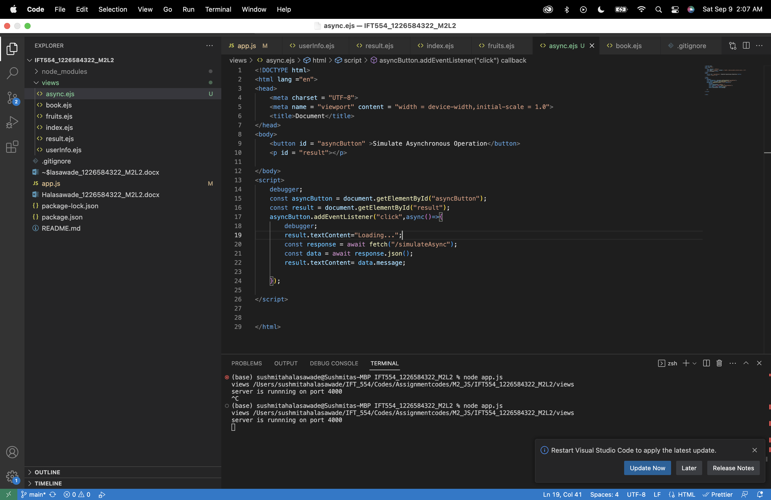

2. Inspect the rendered HTML code in the browser or view the HTML file's source code:

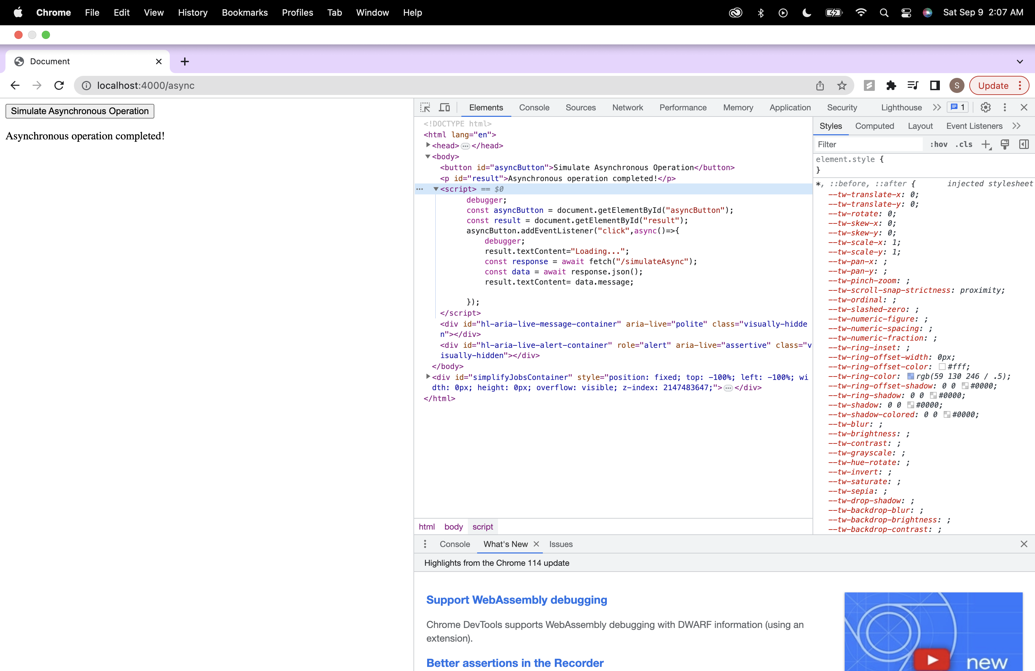

3. Identify the parts of the HTML code that correspond to the JavaScript code in the .ejs file.:

The HTML elements and attributes that correspond to the JavaScript code include:

The button element with id="asyncButton", which is selected and listened to for click events.

The paragraph element with id="result", which is used to display loading and result messages.

4. Compare the rendered HTML code to the original .ejs code and note any differences or modifications.:

<body>

<button id="asyncButton">Simulate Asynchronous Operation</button>

<p id="result">Asynchronous operation completed!</p>

</body>

The rendered HTML code will include the modifications made by the JavaScript code when certain events occur. For example, when the button is clicked, the HTML content is updated to show a loading message and the result of the asynchronous operation.

**Step4: documentation:**

1.Analysis Summary:

The JavaScript code selects HTML elements, adds an event listener, and handles asynchronous operations. This code include dynamic content updates and the simulation of asynchronous operations.

2.Comparison: .ejs vs. HTML:

async.ejs (.ejs Code):

<body>

<button id = "asyncButton" >Simulate Asynchronous Operation</button>

<p id = "result"></p>

</body>

<script>

debugger;

const asyncButton = document.getElementById("asyncButton");

const result = document.getElementById("result");

asyncButton.addEventListener("click",async()=>{

debugger;

result.textContent="Loading...";

const response = await fetch("/simulateAsync");

const data = await response.json();

result.textContent= data.message;

});

</script>

HTML Code Generated in the Browser:

<body>

<button id="asyncButton">Simulate Asynchronous Operation</button>

<p id="result">Asynchronous operation completed!</p>

</body>



3.Observations and Differences:

The JavaScript code within the .ejs file is responsible for enhancing the user experience by providing feedback ("Loading...") during the asynchronous operation and displaying the result once it's available. The code include modern JavaScript features, such as the async/await pattern, to simplify asynchronous programming.

**Step5: Optional Enhancement:**

Modified async.ejs:

<script>

debugger;

const asyncButton = document.getElementById("asyncButton");

const result = document.getElementById("result");

asyncButton.addEventListener("click",async()=>{

debugger;

result.textContent="Loading...";

const response = await fetch("/simulateAsync");

const data = await response.json();

if (data.success) {

result.textContent = data.message;

} else {

result.textContent = "Error occured!.";

}

});

</script>

In .ejs file, I've added a conditional check, it checks if the server response includes a "success" property, the message displayed will vary based on whether the operation was successful or not.

On success:



2. Analyze the corresponding changes in the rendered HTML code and document your findings.

Rendered HTML:

<body>

<button id="asyncButton">Simulate Asynchronous Operation</button>

<p id="result">Asynchronous operation completed!</p>

</body>

I’ve updated the JavaScript code to show different messages based on the success or failure of the asynchronous operation.

**Exercise 6: Async/Await**